1. **Run a discriminant analysis with both predictors using the entire dataset as training data.  Include a screenshot of the Score Summaries.**

**Analyze -> Multivariate Methods -> Discriminant**

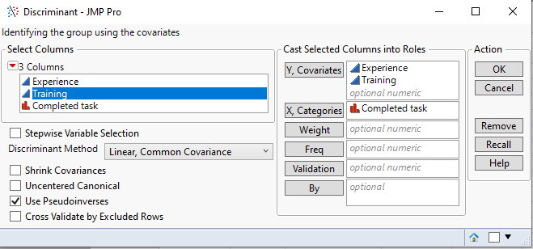

**Score Summaries:**

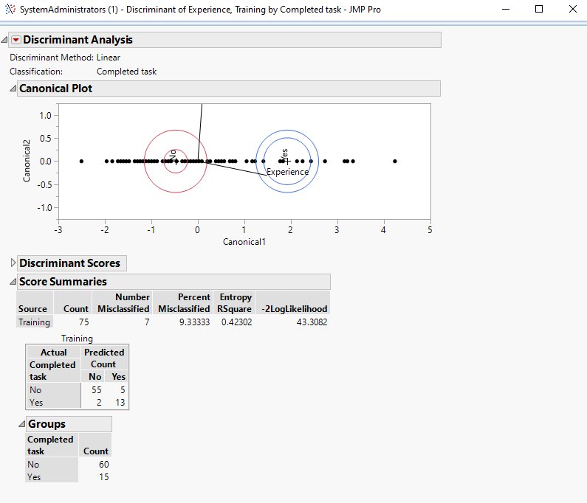

1. **Among those who completed the tasks, what is** **the percentage of administrators who are classified incorrectly as failing to complete the tasks? Why do you think that is? Include screenshots to support your analysis.**

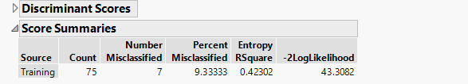

**Percent Misclassified:** Provides the percent of observations in the specified set that are incorrectly classified. 9.3% of administrators are classified incorrectly.

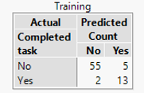

From the confusion matrix, we can observe that out of 15 who completed the tasks, 2 were incorrectly classified. The percentage of administrators who are classified incorrectly as failing to complete the tasks = **2 /15 (13.33%)**

1. **How would you classify an administrator with four months of experience and six credits of training? Include a screenshot.**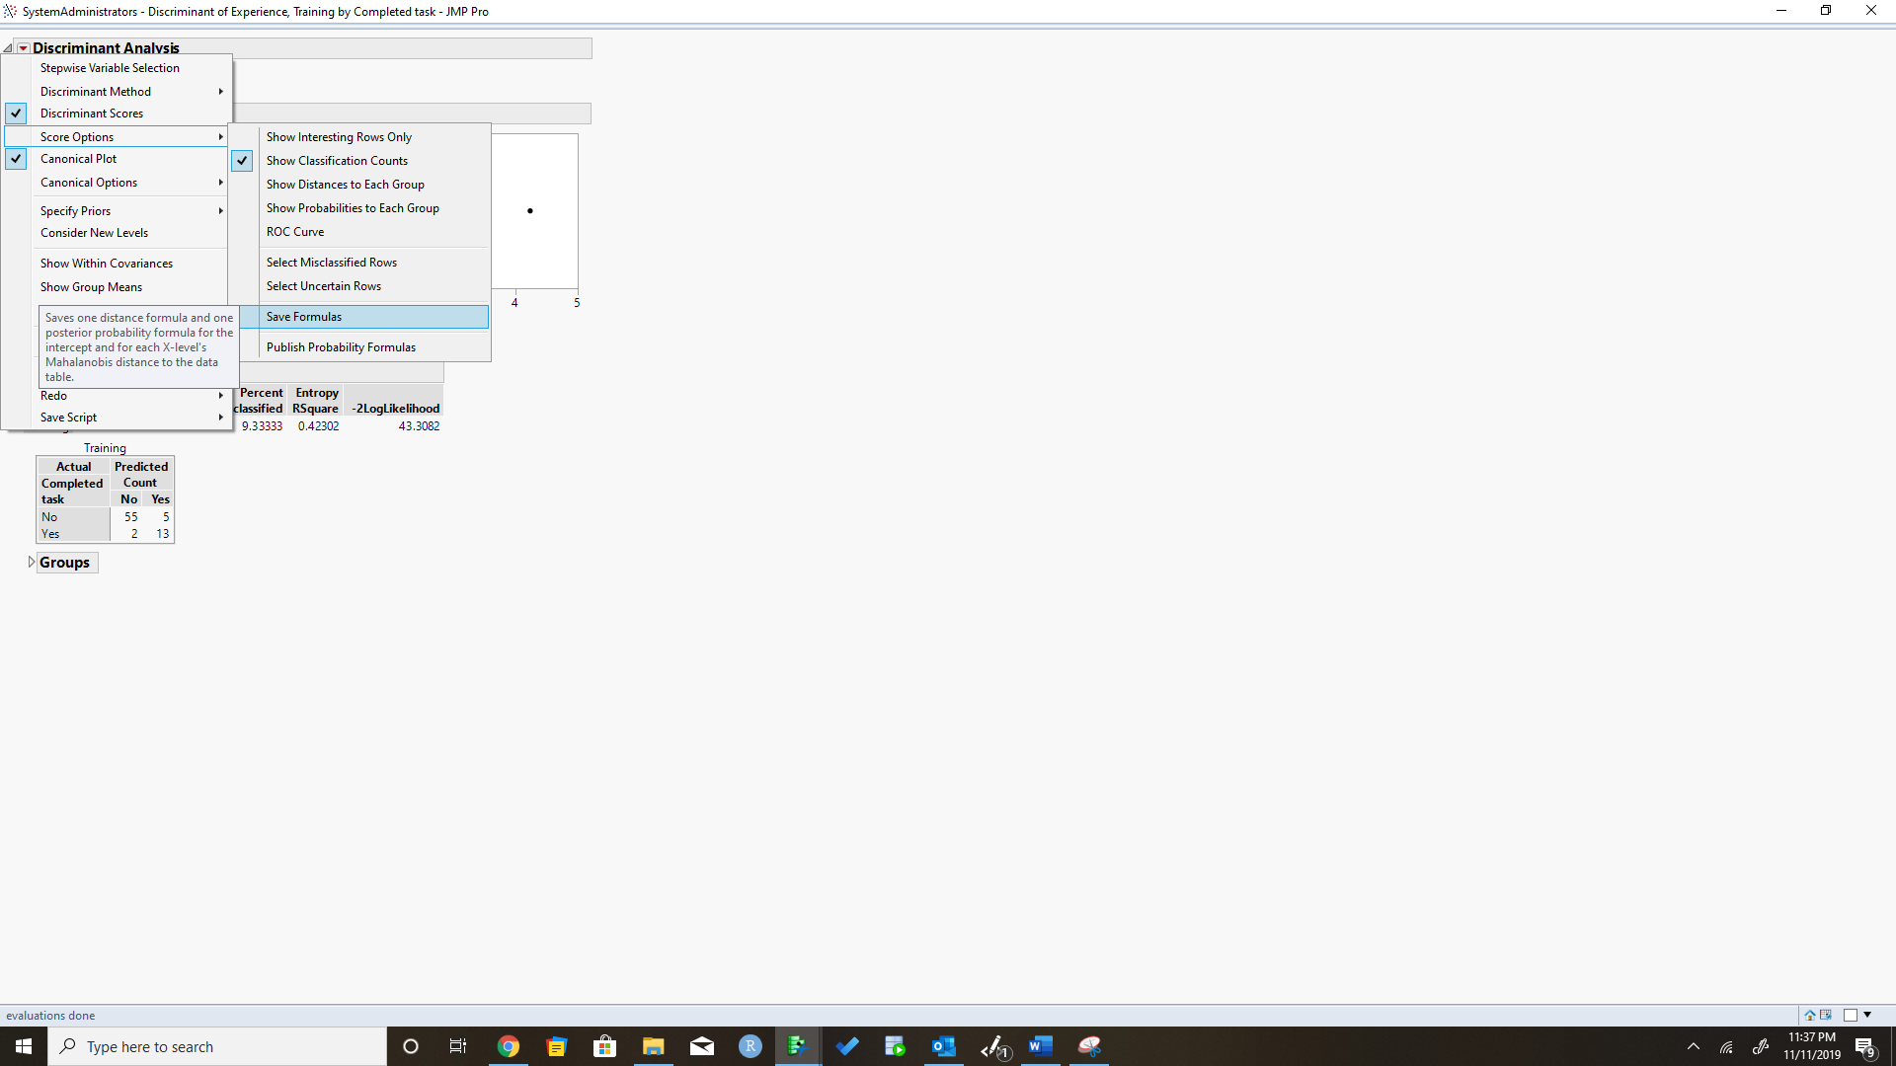

Set the value of experience to 4 months and training to 6 credits and observe the other columns getting automatically populated based on the formula saved.

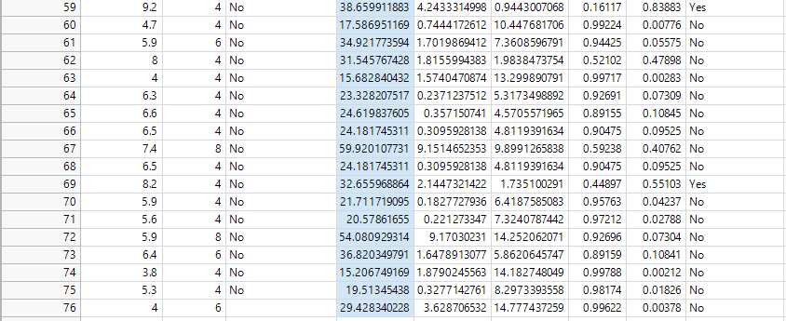

My model predicts a NO foran administrator with four months of experience and six credits of training i.e. he /she will not be able to complete the task.

1. **How much experience** **must be accumulated by an administrator with 4 training credits for his or her estimated probability of completing the tasks to exceed 50%? Why do you think that is? Include screenshot(s) to support your analysis.**

**8.1 or greater months** of experience must be accumulated by an administrator with 4 training credits for his or her estimated probability of completing the tasks to exceed 50%. This was concluded after running a trial-and-error on the values in the Experience column.



For this I introduced a new record with a value of 4 in the Training column and ran a trial-and-error on the values in the Experience column to get an estimated probability of a 50% above YES in the Pred Completed task column.

**5.  Which predictor variable has more impact on the distances?  Why and how do you know? Include screenshots with explanations to justify your answer.**

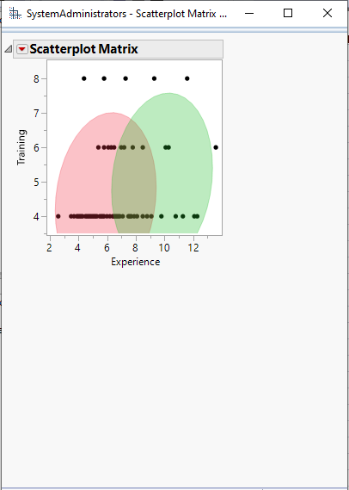

As per the Scatterplot Matrix, Experience has more impact on the distances. With training credit 4, we can see how the completed task varies based on the experience.